**Objectives of this practical**

* To manipulate records of a database via insert, update and delete operations.

Practical 4 – INSERT, UPDATE, DELETE

Contents

Background 3

Section A: Populate Course Table 3

Section B: Populate Department Table 5

Section C: Populate a table 6

Section D: Backup a table 6

Section E: Update records 6

Section F: Delete & Restore records 7

# Background

Sometimes new Information emerges and very often the corresponding data in the database must be changed. As part your day-to-day operations, it is common to create, update and even remove data to maintain the information and keep it current.

# Section A: Populate Course Table

To build up the database gradually, you will populate the database tables with some initial data. In the last practical, the course relation had been defined as shown below.

|  |  |  |  |
| --- | --- | --- | --- |
|  | **Course** | **Primary Key(crse_code)** |  |
|  | **Attribute** | **Data Type** | **Permissible for NULL** |
| 1 | crse_code | VARCHAR(5) | NOT NULL |
| 2 | crse_name | VARCHAR(100) | NOT NULL |
| 3 | offered_by | VARCHAR(5) | NOT NULL |
| 4 | crse_fee | DECIMAL(7,2) | NOT NULL |
| 5 | lab_fee | DECIMAL(7,2) | NULL |

1. Below is the course brochure for School of Business, SB. The classes do not utilize labs so there is no charge for lab fee.

Populate the course table with the given information.



1. The School of Computing, SOC, offers the 4 courses shown below. The classes require the use of lab equipment so there is an associated lab fee.

Populate the course table with the given information.



# Section B: Populate Department Table

In the last practical, the department relation had been defined as shown below.

|  |  |  |  |
| --- | --- | --- | --- |
|  | **department** | **Primary Key(dept_cd)** |  |
|  | **Attribute** | **Data Type** | **Permissible for NULL** |
| 1 | dept_cd | VARCHAR(5) | NOT NULL |
| 2 | dept_name | VARCHAR(100) | NOT NULL |
| 3 | hod | CHAR(4) | NOT NULL |
| 4 | no_of_staff | INTEGER | NULL |
| 5 | max_staff_strength | INTEGER | NULL |
| 6 | budget | DECIMAL(9,2) | NULL |
| 7 | expenditure | DECIMAL(9,2) | NULL |
| 8 | hod_appt_date | DATE | NULL |

|  |  |  |  |  |  |  |  |  |  |
| --- | --- | --- | --- | --- | --- | --- | --- | --- | --- |
| Populate the Department table with the given information. [Do not specify the column list in your insert statements.] | | | | | | | | | |
|  | **Code** | **Department** | **HOD**  **Staff**  **Number** | **Number of Staff** | **Max Number**  **of Staff** | **Budget** | **Expenditure** | **HOD**  **Appointment**  **Date** |  |
| SOC | School of  Computing | S001 | 82 | 92 | 90,000.00 | $45,000.00 | 2009-04-01 |
| DPO | Deputy Principal's  Office | T002 | 3 | 3 | 6,000.00 | NULL | NULL |
| PO | Principal's  Office | T001 | 4 | 4 | 7,500.00 | NULL | 2008-01-01 |
| SB | School of  Business | S006 | 86 | 90 | 80,000.00 | $88,000.00 | 1996-10-01 |

# Section C: Populate a table

Instruction: Download the staff.sql from the LMS.

Insert all the rows for the staff table by executing the staff.sql file.

# Section D: Backup a table

A series of events has been anticipated in the coming month, with various changes to the staff data expected. To mitigate against incorrectly updated data, it is prudent to create a backup. The original data could be restored from it if needed.

Using SQL, create a backup of the staff records to a new table, named staff _backup.

[HINT: Consider creating a table of the same schema, then use INSERT INTO statement.]

# Section E: Update records

The series of events are listed below under Sections E & F. For each scenario, update the table to reflect the changes.

* 1. A salary review was conducted. The school has decided to take up the recommendation from the findings.

Update the data based on the recommendation.



* 1. A new benefits scheme was introduced.

Update the data based on the structure of the new scheme.

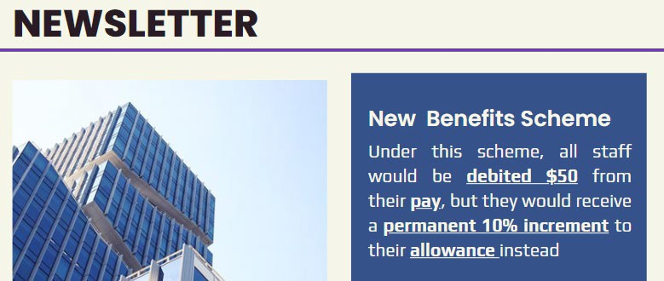

* 1. A special initiative was launched to recognise the efforts of male full-time staff who had joined before the year of 1996. The decision was to acknowledge them with a permanent $100 increment to their pay.

Update the data to reflect the above.

# Section F: Delete & Restore records

1. The staff with staff number T001 left to pursue further education

Remove the corresponding staff record.

1. A few other records were removed by mistake.

* remove all staff records.
* then restore the staff records from the backup that you performed in section D. [Hint: INSERT INTO]

Proceed to